Experimental Setup Procedure

1. Equipment

1.1. Laser (EGISMOS IR Laser Module)
- The is the primary light source for measurement.
- Infrared laser module (Model: S838501D-CU01A).
- Peak Wavelength: Optimized at 852-855 nm.
- Optical power: Stable at approximately 0.78-0.79 mW (rated between 0.6 and 0.9 mW).
- Beam Characteristics: Very Narrow divergence (<1 mrad), producing a small dot).

1.2. Power Supply (AS ONE)
- This will be used to power the Laser.
- Voltage should be set to match the typical operating voltage for this 855 nm laser module.
- Current should be set to match the specific current draw from the laser.
- Over voltage protection must be used to protect the voltage spikes.
- Over current protection must be used to protect the current spikes.

1.3. Detector (Hamamatsu C6386-01 Photosensor AMP)
- This is a high-speed, high-sensitivity “light-to-voltage” conversion system.
- Optical Input: It uses an A9511 optical fiber to capture light, which is useful for measuring narrow or specific points.
- Sensitivity (Range Selection): It can be switched between three ranges depending on signal strength.
- H (High): 10⁵ V/A gain, 1 MHz bandwidth
- M (Medium): 10⁴ V/A gain, 3 MHz bandwidth
- L (Low): 10³ V/A gain, 10 MHz bandwidth
- Power Requirement: it requires a dual power supply (±6 V to ±17 V), standard operation is usually at ±15 V.
- The Hamamatsu datasheet specifically warns not to use a switching power supply; you must use a series power supply (ripple <3 mVp-p) to avoid noise in your measurements.

1.4. Integrating Sphere: ND-Seiko 3-inch Integrating Sphere
- This sphere (Model: NIS-003-03A) is used to collet and spatially integrate the light, likely for measuring the total reflectance or transmittance of samples.
- Interior: Coated with Barium Sulfate (BaSO₄) for high reflectivity.
- Ports: Features three 1-inch ports (0°,90°, and 180°).
- Calibration: Includes a PTFE standard white plate for establishing a 100% reflectance baseline)

1.5. Oscilloscope (Owon SDS1202)
- This is a 200 MHz, 2-channel digital storage oscilloscope to provide the real-time visual graph of the voltage coming out of the Hamamatsu amplifier.
- Signal Visualization: It converts the electrical current from the photodetector into a vertical displacement (Voltage) over a horizontal axis (Time). Since your laser is a continuous wave (CW), you will primarily see a flat horizontal line.
- Measurement Accuracy: the screen provides “Vtop” or “Vmean” reading. This numerical value is what you will record as V_{sample} or V_{std} to calculate phantom’s reflectance.
- Coupling (DC vs AC) : As AC current filter out the steady signals, which would make my constant laser signal drop to zero, DC must be used.
- Vertical Scale (Volts/Div): if the line is too small to measure accurately use smaller value (500 mV/div). If the line disappears from the top of the screen, turn it to a larger value (2V/div).
- Horizontal Scale (Seconds/Div): For a steady laser, a setting of 10 ms is usually perfect to see a stable line.
- Trigger Level: For a steady laser, set the Trigger Mode to “Auto” so the trace refreshes constantly even without a pulse.
- Zero Position: Use this to position to zero when the laser is off.
- Maximum voltage of 300 V (RMS), the amplifier output is up to 10V, always ensure probe is set to 1X in the oscilloscope software menu to match the BNC cable.
- 8-bit oscilloscope. (if 1V/div and there are 8 division, total 8V. resolution is 8/256).
- Because of the 8-bit resolution, we might see “stair-stepping” or “flicker” in line.
- Acquire button on the oscilloscope and change the mode from “Sample” to “Average” (16 or 64) to get stable decimal value.

1.6. Optical Fiber
- This cable is designed to transport the infrared light collected inside the integrating sphere to the Hamamatsu simplifier with minimal signal loss.
- Connectors: SMA-SMA connectors
- Fiber Type: Multimode Fiber (larger core diameter allows it to capture more of the diffuse, scattered light inside the integrating sphere compared to a single-mode fiber).
- Ensure the tips stay clean: a single fingerprint can significantly drop the voltage readings at 855 nm.

2. Cleaning of the Equipment

2.1. Fiber Tip Cleaning (Thorlabs Patch Cable)
The tips of your SMA/FC connectors are where the light enters and exits. Even a microscopic speck of dust can significantly reduce the power reaching detector.
- Tools Needed: Isopropyl alcohol (IPA) 99% purity, lint-free optical wipes (e.g., Kimwipes), and a fiber inspection scope (if available).
- The "Fold and Swipe" Method:
  - Inspect: Look at the tip. If you see a smudge or dust, do not touch it with your finger.
  - Prepare Wipe: Take a fresh lint-free wipe and dampen a small area with IPA.
  - The Swipe: Hold the connector vertically. Drag the fiber tip across the damp part of the wipe in a single, smooth "S" motion. Do not scrub back and forth, as this can grind dust into the glass.
  - Dry: Immediately repeat the motion on a dry section of the same wipe to remove alcohol residue (which can leave "halos").
- Safety: Never investigate the end of a fiber while the laser is on, even if it is an invisible wavelength like your 855 nm laser.

2.2. Integrating Sphere Surface Cleaning (ND Group Sphere)
Sphere is coated with Barium Sulfate (BaSO₄). This is a highly reflective but very fragile "soft" coating. It is not a solid paint; it is more like a compressed powder.
- Rule Number One: NEVER touch the inside of the sphere. The oils from the skin will permanently stain the coating and change its reflectance properties.
- Loose Dust: Use a clean, dry "air puffer" (like those used for camera lenses) to blow out loose dust.
  - Warning: Do not use "canned air," as the chemical propellants can spray liquid onto the coating and leave permanent spots.
- Minor Stains: If a small piece of debris is stuck, you can very gently attempt to remove it with a dry, clean specialized optical swab. Do not use water or solvents, as these will likely dissolve or smear the BaSO₄ coating.
- Major Damage: If the coating is yellowed or heavily scratched, the sphere must be sent back to the manufacturer for recoating. This is why you should always keep the Covers on the ports when the sphere is not in use.

2.3. Reference Standard Plate Cleaning (PTFE)
Your PTFE White Standard Plate is much more durable than the sphere interior, but it still needs to stay "pure white" to remain 99% reflective.
- Daily Cleaning: Blow off dust with an air puffer.
- Deep Cleaning: Since PTFE (Teflon) is chemically inert, you can clean it with 99% IPA and lint-free cloth if it becomes smudged.
- Resurfacing: If the plate becomes permanently stained or scratched, you can lightly sand the surface with very fine grit (e.g., 200–400 grit) waterproof silicon carbide sandpaper under running deionized water. This "refreshes" the white surface. Always dry it completely before use.

3. Setting up Experiment

3.1. Laser Power Supply (AS ONE PS30V5A01)
This unit provides the stable energy required for your 855 nm laser.
- Connection: Connect the Red (+) and Black (-) leads to the corresponding wires on the EGISMOS laser module.
- Voltage Setting: Set the output to exactly 3.300 V.
- Safety Limits: * Set O.V.P (Over Voltage Protection) to 3.500 V.
  - Set O.C.P (Over Current Protection) to 0.030 A (30 mA).
- Verification: Once turned on, the current display should read approximately 0.013 A (13 mA). If it is significantly higher or lower, power down immediately to check connections.

3.2. Photosensor Amplifier (Hamamatsu C6386-01)
The amplifier converts the light signal from the fiber into a voltage.
- Power: Use a linear DC power supply (not a switching one) to provide ±15 V.
- Gain Setup (Rf RANGE): * Set the toggle switch to M (Medium) as a baseline.
  - If your oscilloscope signal is below 50 mV, switch to H.
  - If your signal exceeds 10 V (clipping), switch to L.
- Zeroing: With the laser, OFF and the sphere ports covered:
  - Observe the oscilloscope trace.
  - Use a precision screwdriver to turn the ZERO ADJ. trimmer until the trace sits exactly on the 0 V horizontal line.

3.3. Integrating Sphere (ND Group NIS-003-03A)
The sphere collects scattered light. Proper port management is vital for IAD accuracy.
- Reflectance Configuration: * Place the Laser at the180° port.
  - Place the Sample (or PTFE White Plate) at the 0° port.
  - Connect the Fiber to the 90° port.
- Transmittance Configuration: * Place both the Laser and the Sample at the 0° port.
  - Cover the 180° port with a black plug or leave it open to a dark room to prevent back reflection.
- Internal Check: Ensure the internal Baffle is positioned between the sample port 0° and the detector port 0° to prevent "first strike" light from hitting the sensor directly.
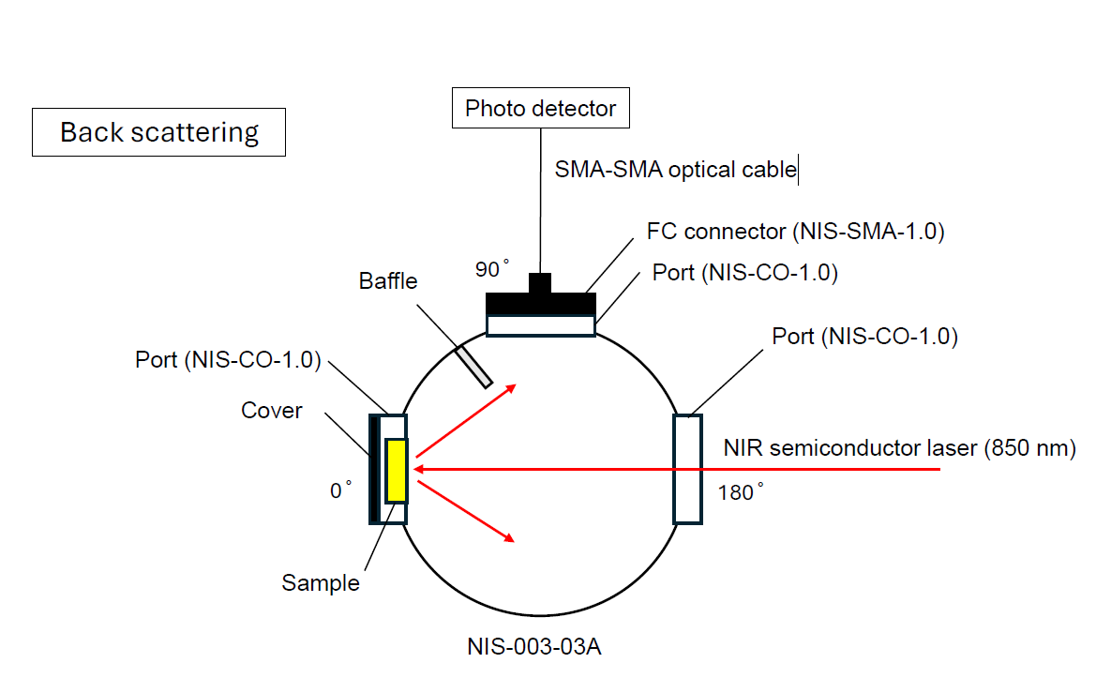
Fig. Experiment Setup Diagram for Back Scattering
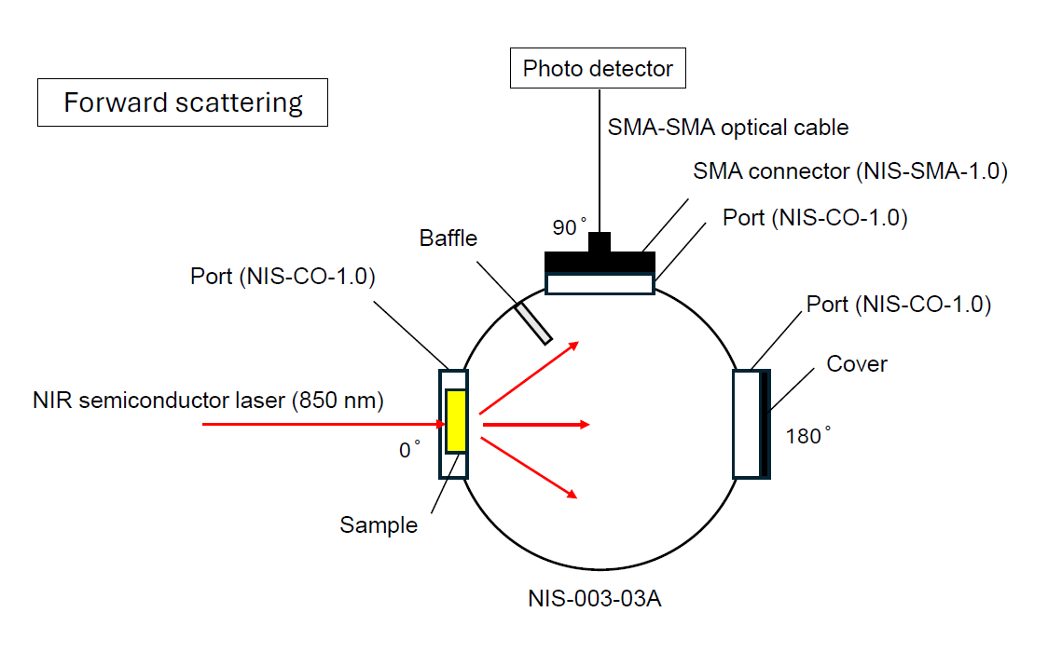
Fig. Experiment Setup Diagram for Forward Scattering
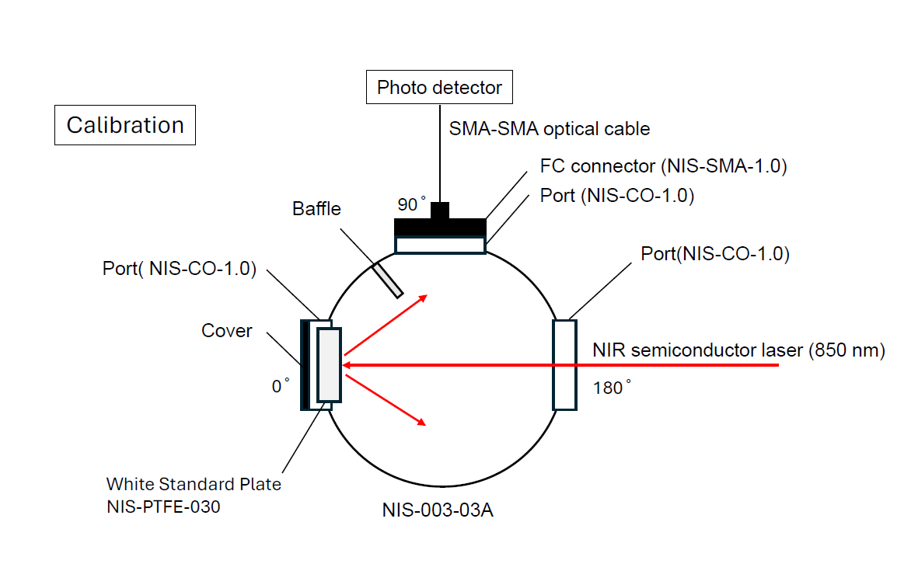
Fig. Experiment Setup Diagram for Calibration

3.4. Fiber Optic Cable (Thorlabs Patch Cable)
This transports the light from the sphere to the detector.
- Cleaning: Use a lint-free wipe and 99% Isopropyl Alcohol to clean the tips in a single-direction "S" motion.
- Connection: Screw the SMA connectors finger tight. Do not use tools, as over-tightening can crack the fiber face.
- Routing: Ensure the cable has a "relaxed" curve. A bend radius smaller than 15 mm will cause significant signal loss and measurement errors.

3.5. Oscilloscope (Owon SDS1202)
The scope visualizes and measures the final voltage.
- Channel 1 Menu:
  - Coupling: Set to DC.
  - Invert: Set to ON. (The Hamamatsu circuit often produces a negative voltage for light increase; inverting makes the data intuitive: more light = higher positive voltage).
  - Probe: Set to 1X.
- Vertical Adjust: Set Volts/Div so the signal occupies at least 50% of the screen height to maximize the 8-bit resolution.
- Acquisition Mode: Press the Acquire button and select Average (16 or 64). This filters out electrical noise and gives you stable numerical value for your calculations.

4. Data Collection

4.1. Data copying from the Oscilloscope
- Format the USB drive with FAT32.
- When plugged in, USB connected message should appear on the screen.
- Save/Recall button to save the raw data point.
- Change the data type.
- Check the data source, (CH 1).
- Can change the name using the object knob.
- Can save PNG.
- Can use print/copy to use the setting immediately.
- Voltage and Time graph can be produced.
- The Value: Since your laser signal is a steady DC level, the rows will all have very similar values. Average these rows to get a single, stable voltage number. This helps eliminate the "8-bit noise" and gives you a much cleaner input for the Inverse Adding-Doubling (IAD) program.
- Use the average value of Voltage column to further process.

5. Measurement procedures

5.1. Integrating Sphere calibration
The sphere wall reflectance r_{w} is critical. Two measurements are needed for this experiment.
$$\frac{1}{r_{w}}=a_{w}+a_{d}r_{d}\left(1-a_{e}\right)+a_{s}r_{std}\left(1-a_{e}\right)\frac{R_{std}^{diffuse}}{R_{std}^{diffuse}-R_{0}^{diffuse}}$$

The two diffuse reflectance $R_{std}^{diffuse}$and $R_{0}^{diffuse}$will only differ the amount of diffuse light leaking from the sphere when the port is empty. Consequently, the difference will be small and any error in the measurement will be magnified when the division is done.
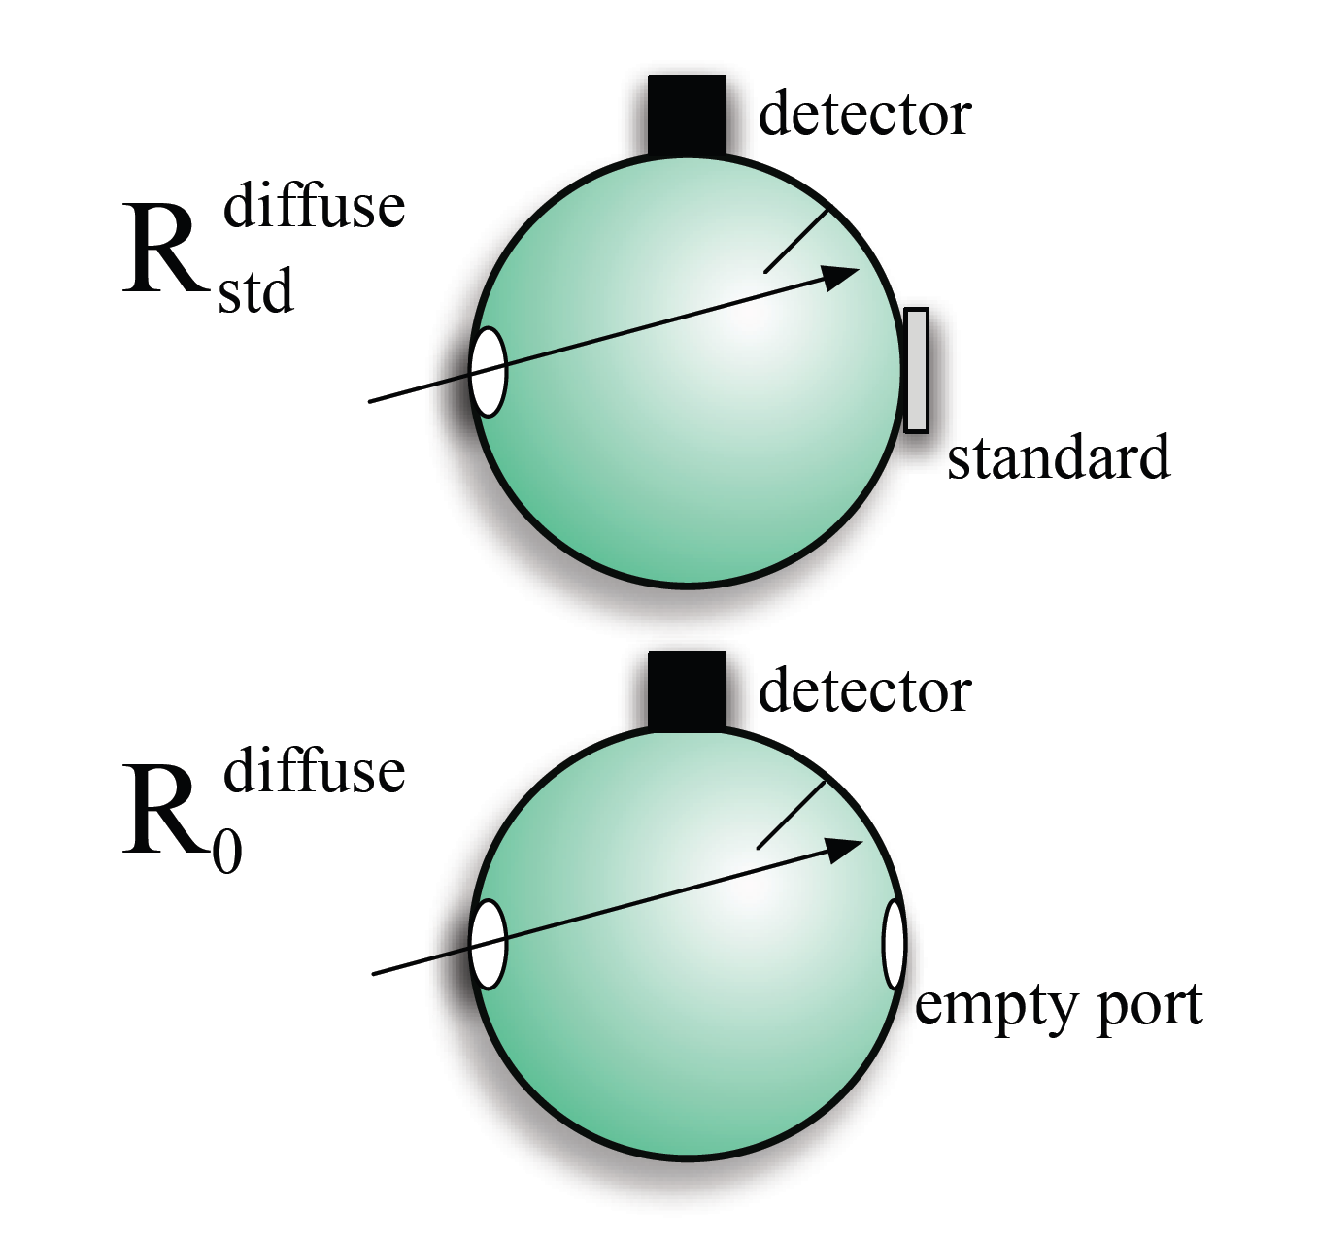
Fig. The two experiments need to determine the sphere wall reflectance.
The reason that this is a hard experiment to do well is that the quality of interest is the difference between the two measurements. This is a small difference and is roughly proportional to relative area of the sample port a_{s}.
Method to obtain $R_{std}^{diffuse}$and $R_{0}^{diffuse}$:
- Needed to record two primary voltages from the oscilloscope.
- V_{std} this is from the calibration reference. (100% reflectance).
- V_{sample} this is from the measurement of the sample.
- V_{dark} this is from the measurement of the sample or white plate in place and measured at 0 light.
$$R_{sample}^{diffuse}=r_{std}×\frac{V_{sample}-V_{dark}}{V_{std}-V_{dark}}$$

5.2. Single Sphere M_{R} and M_{T}
Standard usage is that:
- Reflection is the light being reflected by the sample.
- Reflectance is the light being reflected by the sample normalized by the incoming light. (No unit).
- A stable useful estimate for the reflectance of the sample is the measured total reflectance (M_{R}), which is defined in terms of easily measurable sample, standard, and background reflection measurements.
- The value of M_{R} differs from the true reflectance because the gain of the integrating sphere varies with the sample reflectance.
$$M_{R}=r_{std}×\frac{R\left(r_{s}^{direct},r_{s}\right)-R\left(0,0\right)}{R\left(r_{std},r_{std}\right)-R\left(0,0\right)}$$

The same idea applies to transmission and transmittance.
- Transmission is the light being transmitted by the sample.
- Transmittance is the light being transmitted by the sample normalized by the incident power.
- The measured total transmittance M_{T} is defined by:
$$M_{T}=\frac{T\left(t_{s}^{direct},r_{s}\right)-T_{dark}}{T\left(0,0\right)-T_{dark}}$$

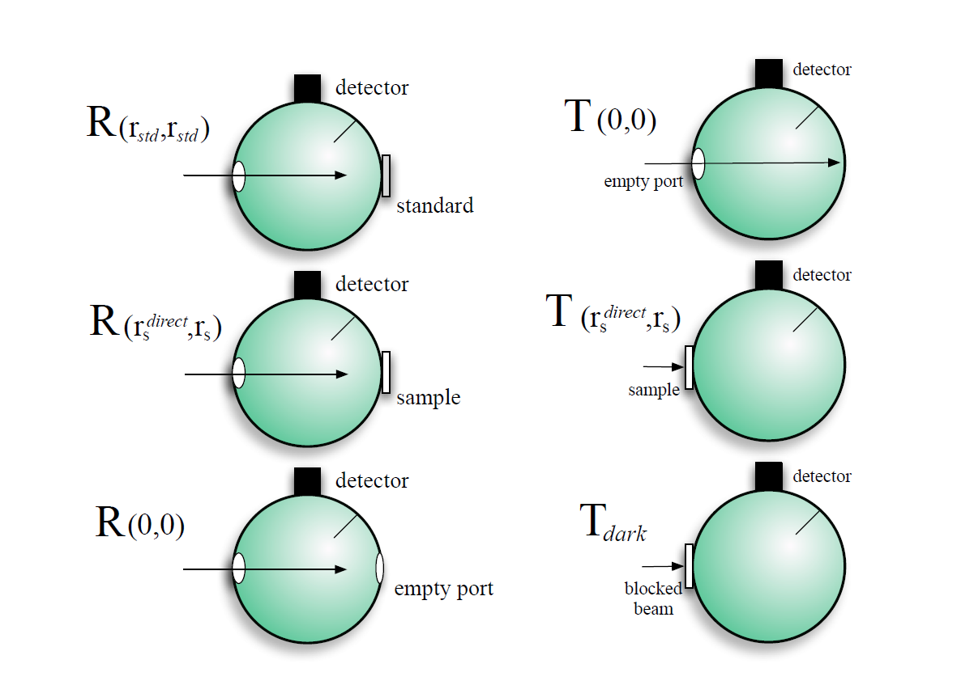
Fig. The measurements needed to measure the M_{R} and M_{T}.
The baffle is always located between the sample and the detector. The back wall of the transmission sphere is never open (light that does not interact with sample bounces in the sphere). T_{dark} and T (0,0) are very different.

5.3. Measured Un-scattered Transmittance
The measured un-scattered transmittance M_{U} is the amount of light that gets through the sample without being scattered or absorbed. This has been called by different terms: collimated transmittance, ballistic transmittance, on-axis transmittance and coherent transmittance.
$$M_{U}=\frac{U_{s}-U_{0}}{U_{100}-U_{0}}$$
U indicated an un-scattered measurement.
U_{s} refers to the un-scattered sample transmission.
U₀ is the background measurement for the un-scattered transmission measurement (beam blocked).
U₁₀₀ is the un-scattered transmission measurement when no sample is present.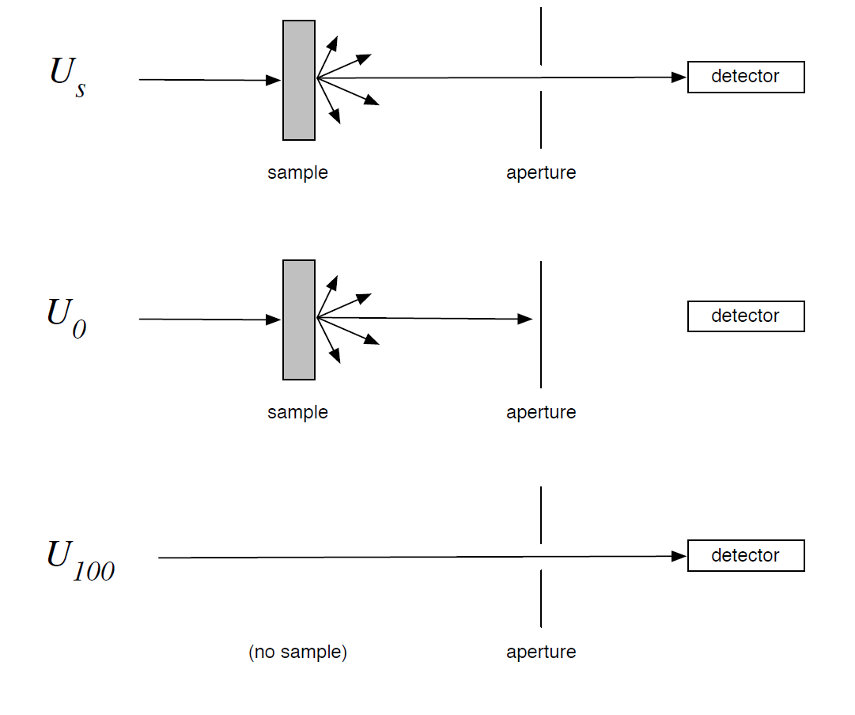
Fig. Measurement needed to determine M_{U}
[Error Checking procedure for M_{U}]

5.4. Properties

5.4.1. Sphere Properties
A area [mm²]
a area divided by the total sphere wall area
X_{d} (subscript d) detector
X_{w} (subscript w) sphere wall (ports excluded)
X_{e} (subscript e) entrance
X_{s} (subscript s) sample
X_{b} (subscript b) beam

5.4.2. Sample Properties
δ sample thickness [mm]
µ_{a} absorption coefficient [mm⁻¹]
µ_{s} scattering coefficient [mm⁻¹]
µ_{s}’ reduced scattering coefficient = µ_{s} (1 - g) [mm⁻¹]
g anisotropy, (average cosine of phase function)

5.4.3. Idealized Values
r true reflectance
t true transmittance

5.4.4. Observables
R un-normalized reflection arbitrary
T un-normalized transmission arbitrary
U un-normalized un-scattered transmission arbitrary
M_{R} measured total reflectance
M_{T} measured total transmittance
M_{U} measured total un-scattered transmittance
X₀ (subscript 0) empty or nothing
X₁₀₀ (subscript 100) all
X_{std} (subscript std) reflectance standard
X_{dark} (subscript dark) blocked beam
X^{diffuse} (superscript diffuse) diffuse illumination (generally omitted)
X^{direct} (superscript direct) direct or normal illumination

The above are the nomenclatures used in this experiment.
A_{s} is the area of the sample port and a_{d} is A_{d} / (A_{w} + A_{e} + A_{s} + A_{d} ).
$r_{s}^{direct}$ describes the true reflectance from the sample for direct (normal) illumination and r_{s} is the sample port reflectance for diffuse illumination (where the diffuse superscript has been omitted)

6. Parameter for Inverse Adding Doubling

